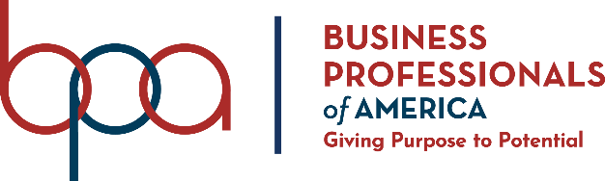
Contestant Number:
Time:
Rank:

Human Resource Management
(535)

STATE – 2020

FINAL

Presentation Points (140 points)

Specification Points (20 points)

TOTAL POINTS (160 points)

Failure to adhere to any of the following rules will result in disqualification:
- Contestant must hand in this test booklet and all printouts. Failure to do so will result in disqualification.
- No equipment, supplies, or materials other than those specified for this event are allowed in the testing area. No previous BPA tests and/or sample tests or facsimile (handwritten, photocopied, or keyed) are allowed in the testing area.
- Electronic devices will be monitored according to ACT standards.

No more than ten (20) minutes preparation
No less than three (3) and no more than five (5) minutes oral presentation
No more than three (3) minutes judges’ questions

Property of Business Professionals of America.
May be reproduced only for use in the Business Professionals of America
Workplace Skills Assessment Program competition.

Description
Assess interpretation of personnel policies and knowledge of human resource management.

State Final Scenario:
Professional Business Associates had a recent opening for a payroll specialist in the finance department. As a recruitment tool, the company used LinkedIn to search for potential candidates based on having a two-year business degree with accounting experience or a bachelor’s degree in finance. Several candidates were identified but Kaitlyn Brown stood out because of her bachelor’s in finance degree and her experience working in the business field. She quickly became a well-liked and reliable part of the PBA team.

Several months after her hire, it was discovered that Kaitlyn had never completed her bachelor’s degree after having failed three classes.

As a Human Resources Manager, how would you handle this situation? Use your Human Resources Manual as a guide.

A contestant will be DISQUALIFIED for violations of the Copyright and Fair Use Guidelines.

Contestants who do not submit an entry that follows this topic will be disqualified.

